## Class notes

Bc batch calculator

Use ctrl d to exit editor

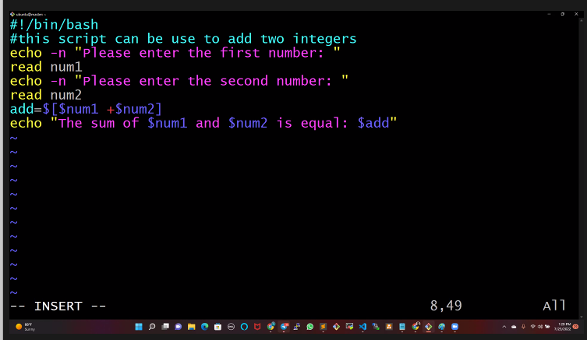

read -p “enter your name: “ name

read -p “enter your address: “ address

or

enter -n “enter your name: “

read name

:wq! Save and quit.

:q! quit without saving

Blkid

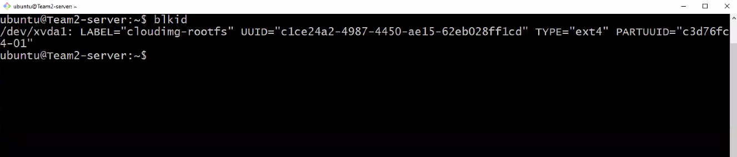



http://ec2-54-244-212-162.us-west-2.compute.amazonaws.com:3000